Cátedra: INGLÉS TÉCNICO I Carrera: DESARROLLO DE SOFTWARE.
Name: Date:
Practical Work I
COMPUTERS
- Fill in the blanks with these words.
machine technology social logical calculations editing communication
A computer is a programmable machine designed to automatically carry out a sequence of arithmetic or ………………operations. The first use of the word "computer" was recorded in 1613, referring to a person who carried out……………………., or computations, and the word continued with the same meaning until the middle of the 20th century. From the end of the 19th century the word began to take on its more familiar meaning, a …………………….that carries out computations.
In the beginning, computers were as big as a large room. It is only later that they have become smaller and smaller, accessible to anyone. This has given way to personal computers. Later developers created new applications to help users perform many things from word processing to image………………………. A large scale of programs, some free and others costly, have opened new horizons in information …………………………….
Now computers have noticeable impact on ………………..relations. They have enabled entirely new forms of social interaction, activities, and organizing. With the Internet, working with computers has become part of our daily lives thanks to its basic features such as widespread usability and access. In addition to face to face …………………………….that characterized humans for centuries, a new form of virtual communication has become more predominant.
- Write TRUE or FALSE.
- The word computer is a new term.
- Computers were accessible to anyone in the beginning.
- All computer applications are free.
- Computers and the Internet have shaped new social relations.

- Match the words with each definition.

- arithmetic operations automatic device.
- machine computer programmer.
- applications programmes
- developers addition, subtraction, multiplication and division,

- Complete the text with correct forms of the present tense.
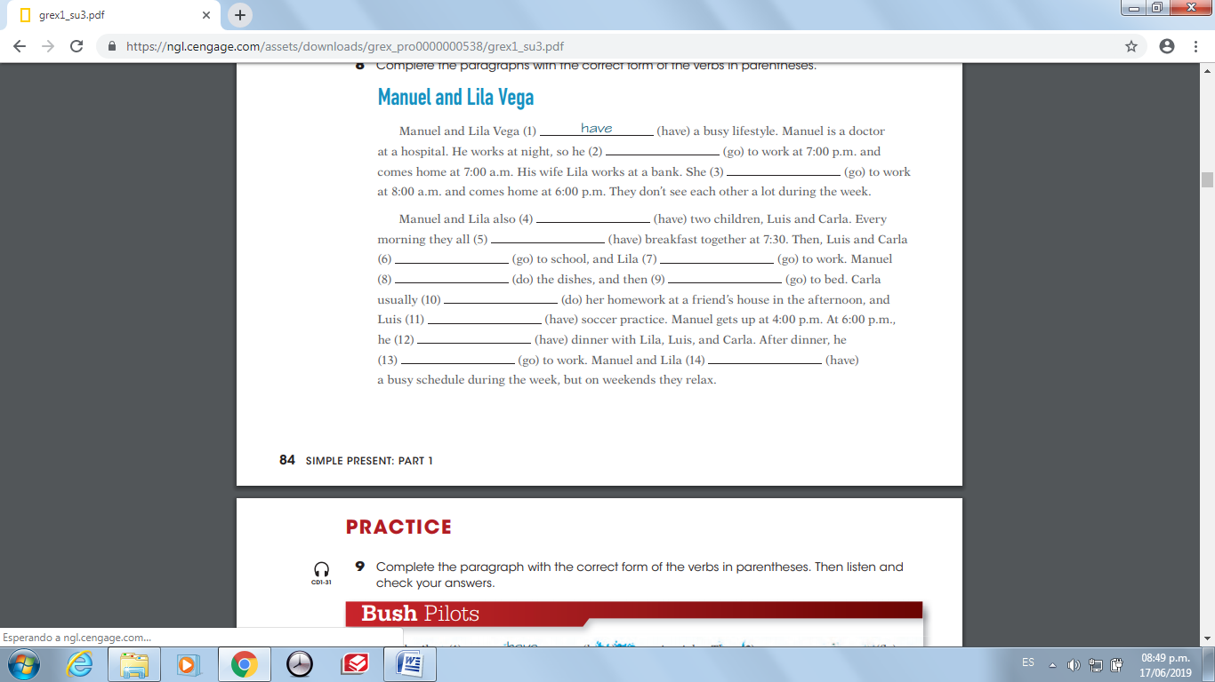

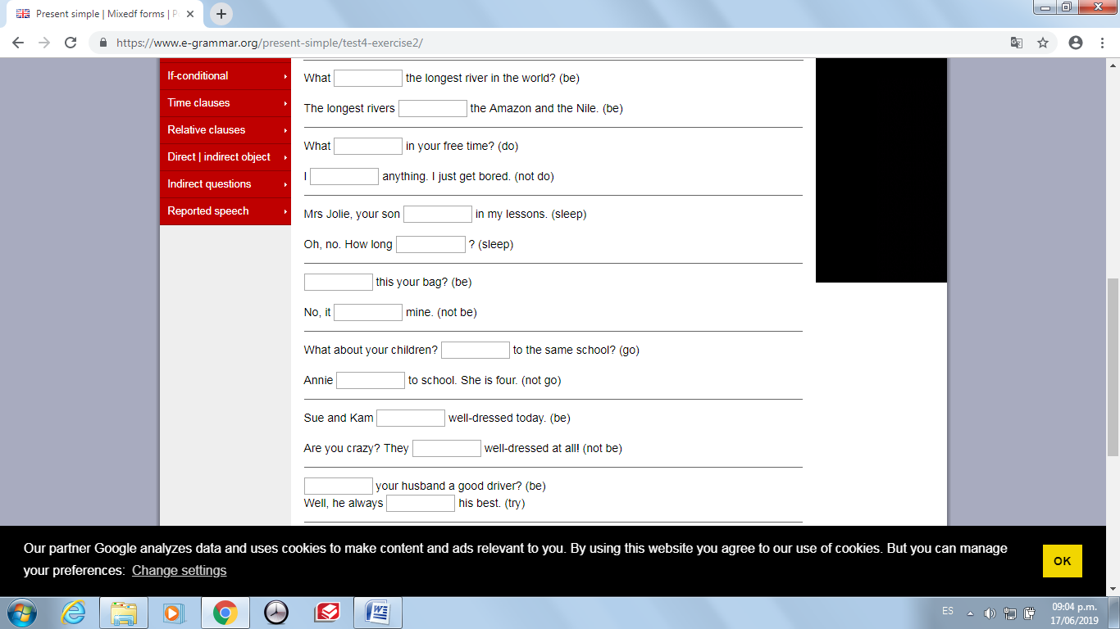
- Complete the dialogues.

